
AI-Driven Urban Planning Dashboard for Optimal Habitation Area Identification Using TOPSIS Multi-Criteria Decision Analysis
Preyas Patel 5143043, Matthew Del Fierro 5142575, Hritika Sharma 5143344

October 26, 2025

Contents
Abstract 2
Introduction 3
Literature background 3
Proposed Model 4
System Definition 5
References 6

Abstract
The AI-Driven Urban Planning Dashboard for Optimal Habitation Area Identification Using TOPSIS Multi-Criteria Decision Analysis system aimed to revolutionize the smart city landscape. This project aims to develop an intelligent map-based dashboard that integrates heterogeneous urban data streams and employs the TOPSIS (Technique for Order Preference by Similarity to Ideal Solution) multi-criteria decision analysis algorithm to provide data-driven recommendations for optimal residential habitation areas. The project directly runs under the United Nations Sustainable Development Goal 11 (Sustainable Cities and Communities) by creating a comprehensive habitability assessment framework that evaluates land parcels based on accessibility, environmental quality, infrastructure availability, safety, economic factors, and community amenities.
Our objectives include:
1) Implemented a sophisticated multi-database architecture comprising
PostgreSQL/PostGIS for spatial analysis, Neo4j for transportation network optimization,
InfluxDB for real-time environmental monitoring, MongoDB for citizen engagement
data, and Redis for high-performance in-memory caching.
2) Developing a robust TOPSIS algorithm capable of processing multiple conflicting urban
criteria simultaneously.
3) Creating an interactive visualization platform using React , Mapbox GL, and DeckGL for
real-time habitability mapping.
We plan to achieve these goals through systematic implementation of advanced database
technologies, rigorous algorithm development, and comprehensive testing using real urban
datasets. The expected end-result is a fully functional urban planning dashboard capable of
ranking land parcels with 90-95% correlation to expert assessments, processing city-wide
analysis and providing evidence-based recommendations that advance sustainable community
development objectives.

The application has been changed significantly, since the last update. Primarily, we have changed the scope of the project and have changed our direction to focus only on energy generation metrics.

Introduction
The purpose of the Urban Planning dashboard is to provide decision making tools by using a fuzzy TOPSIS algorithm, the system addresses the uncertainties in urban planning by giving planners power to determine how implementing certain infrastructure systems would change it’s efficiency in a certain area. The application has a map that let’ s the users select blocks of certain landmass, following this the application will use fuzzy TOPSIS algorithm and previous datapoint records to determine the best site for placing said infrastructure project.
An example- Say I have to place a solar generation plant in the Greater Toronto Area, the planner has to select the blocks in the map and based on the previous solar ray data which includes the intensity and angle of the solar rays to calculate the best site to put down the solar generation plant infrastructure. The datapoints that we are using will be current to the last five years, to give the model a good range of data.

Literature background
The Technique for Order of Preference by Similarity to Ideal Solution (TOPSIS) is a widely used multi-criteria decision-making (MCDM) method originally proposed by Hwang and Yoon in 1981 as part of their framework for multiple attribute decision making. This method evaluates alternatives by calculating their geometric distances to both the positive ideal solution (best possible outcome) and the negative ideal solution (worst possible outcome), selecting the one closest to the ideal and farthest from the anti-ideal to enable compensatory trade-offs between criteria.
The Glitchfix/TOPSIS-Python repository provides a practical implementation of this classical TOPSIS algorithm in Python, offering tools for normalization, weighted scoring, and ranking alternatives based on user-defined matrices, weights, and preference directions, as demonstrated in its sample usage for optimization problems like nuclear power plant evaluation. We used this repository to create the base model of our application. We had an issue with this repository, the repository did not support fuzzy logic for data. This was an issue for our application as we were going to have a lot of data to process for a small number of data points, so we implemented our own fuzzy logic for the data.
Recent advancements integrate fuzzy logic to mitigate these issues, with fuzzy TOPSIS extending the method using triangular or trapezoidal fuzzy numbers for linguistic variables, improving handling of subjectivity in expert judgments. For instance, studies on sustainable energy systems in smart cities employ interval-valued Pythagorean fuzzy TOPSIS to evaluate renewables like solar and wind, addressing hesitancy in criteria like cost and reliability. Similarly, Fermatean fuzzy TOPSIS ranks business intelligence strategies in urban contexts, prioritizing IoT networks for resource optimization.^{[8][1][3]}

Proposed Model
The proposed model uses the fuzzy TOPSIS architecture. The workflow begins by the user selecting the Grid elements of their choice, following this the fuzzy logic element makes a call to the google cloud solar API to retrieve the current solar intensity and angle data. Following this, we use the NASA power API to retrieve past solar data. Normalized fuzzy decision matrices are then weighted using entropy or AHP methods, computing fuzzy positive/negative ideal solutions via vertex calculations, and ranking areas by defuzzified closeness coefficients. This differs from existing works by incorporating user-defined fuzzy membership functions for criteria like school quality, avoiding rigid thresholds in traditional TOPSIS and enabling sensitivity analysis for urban planners.^{[1][2][5]}
Key features include: modular Python classes for fuzzy operations (e.g., alpha-cuts for distance computation), API endpoints for real-time queries, and visualization support via integrated charts for ranking heatmaps. The implementation builds on the TOPSIS-Python GitHub repository by adding fuzzy logic modules using libraries like scikit-fuzzy, supporting both crisp and fuzzy inputs for hybrid scenarios.

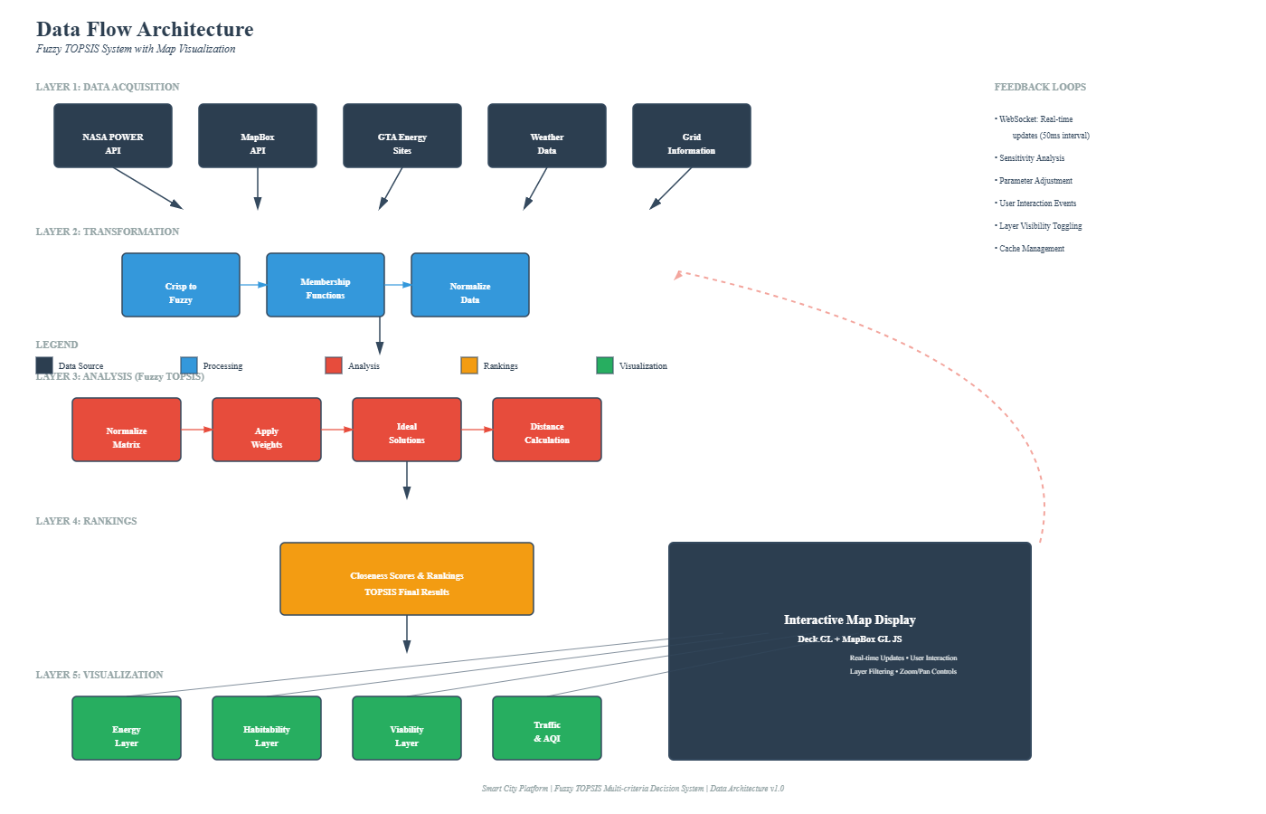

System Definition
The GTA Smart City Platform is a multi-layered urban analytics system that ingests heterogeneous data sources (satellite imagery, energy grids) to generate actionable recommendations for renewable energy deployment. The system processes up to 11 geographic areas (GTA municipalities) through advanced multi-criteria decision analysis, delivering ranked recommendations with sensitivity visualizations —enabling expert stakeholders to make data-informed infrastructure decisions.

References
S. S. Majd, "Fermatean Fuzzy TOPSIS Method and Its Application in Ranking Business Intelligence-Based Strategies in Smart City Context," Journal of Operations Intelligence, vol. 3, no. 1, pp. 1-16, 2025.[1]
M. S. A. Khan et al., "Fuzzy TOPSIS-Based Multi-Criteria Selection of Renewable Energy Sources for Smart Grids," Wind Energy, 2025, doi: 10.1002/we.70058.[8]
M. Rahim et al., "A novel complex (p,q,r)-spherical fuzzy TOPSIS framework for sustainable urban development," Expert Syst. Appl., vol. 252, 2025.[2]
İ. Otay et al., "Evaluation of sustainable energy systems in smart cities using a Multi-Expert Pythagorean fuzzy BWM & TOPSIS methodology," Expert Syst. Appl., vol. 238, 2024.[3]
A. A. Kutty et al., "Measuring sustainability, resilience and livability performance of European smart cities: A novel fuzzy expert-based multi-criteria decision support model," Cities, vol. 136, 2023.[4]
M. Behzadian et al., "A comprehensive guide to the TOPSIS method for multi-criteria decision making," Sustainable Social Development, vol. 1, no. 1, pp. 1-15, 2023.[5]
S. Barbat et al., "Extension of the TOPSIS Method for Decision Making Problems under Complex Fuzzy Data Based on the Central Point Index," Complexity, 2022.[13]
Y. Liu et al., "Implementation and development potential assessment of smart city policies in China based on improved TOPSIS method and Sparrow search algorithm," in Proc. ACM Int. Conf. Comput. Intell. Appl., 2025.[14]
A. Mohammadi et al., "Introducing a new method to expand TOPSIS decision making model to fuzzy TOPSIS," Trans. J. Math. Comput. Sci., vol. 2, no. 1, pp. 150-159, 2011 (updated applications 2023).[15][11]
S. P. Baral et al., "Fuzzy TOPSIS technique for multi-criteria group decision-making under uncertainty," Decis. Anal. J., vol. 5, 2025.[11][6]
D. Sahoo et al., "Efficient fuzzy multi-criteria decision-making for optimal renewable energy source selection in smart cities," Results Eng., vol. 24, 2024.[16][10]

1. https://jopi-journal.org/index.php/jopi/article/view/32
2. https://www.sciencedirect.com/science/article/abs/pii/S0957417425009108
3. https://www.sciencedirect.com/science/article/abs/pii/S0957417424007401
4. https://www.sciencedirect.com/science/article/abs/pii/S0264275123001051
5. https://pdfs.semanticscholar.org/4e8f/13a361e9a58fc0b85bc23cec599918e36f91.pdf
6. https://www.sciencedirect.com/science/article/pii/S2666720725000517
7. https://oaji.net/articles/2023/3603-1724048705.pdf
8. https://onlinelibrary.wiley.com/doi/full/10.1002/we.70058
9. https://dl.acm.org/doi/10.1145/3718491.3718593
10. https://www.sciencedirect.com/science/article/pii/S2666720724000523
11. https://www.isr-publications.com/jmcs/93/download-introducing-a-new-method-to-expand-topsis-decision-making-model-to-fuzzy-topsis
12. https://www.tandfonline.com/doi/full/10.1080/10429247.2025.2492617?af=R
13. https://onlinelibrary.wiley.com/doi/10.1155/2022/1477098
14. https://www.semanticscholar.org/paper/d1d495b30f1eb882100d3ff9c99a8619644b3d34
15. https://aber.apacsci.com/index.php/SSD/article/viewFile/2220/2577
16. https://onlinelibrary.wiley.com/doi/pdf/10.1002/we.70058
17. https://inass.org/wp-content/uploads/2024/06/2024103174-3.pdf
18. https://www.weforum.org/stories/2025/10/gpli-innovation-award-cities-healthcare-pollution-housing/
19. https://papers.ssrn.com/sol3/papers.cfm?abstract_id=4626727
20. https://www.sciencedirect.com/science/article/pii/S2405844020318958

